Real-Time Object Classification: Shape and Size Analysis with Computer Vision on Arduino
Sekhar Chipurupalli Surendra Koppala Uday Kiran Vadaga Ramya Vana Surya Venkat Konduru Ruthvik Vadarevu

¹ Associate Professor, Dept of CSE(AIML), GMRIT, Rajam, Andhra Pradesh 532127, INDIA
sekhar.ch@gmrit.edu.in
² Dept of CSE(AIML), GMRIT, Rajam, Andhra Pradesh 532127, INDIA
surendrakoppala07@gmail.com
³ Dept of CSE(AIML), GMRIT, Rajam, Andhra Pradesh 532127, INDIA
udaykiran0712@gmail.com
⁴ Dept of CSE(AIML), GMRIT, Rajam, Andhra Pradesh 532127, INDIA
ramyavana2004@gmail.com
⁵ Dept of CSE(AIML), GMRIT, Rajam, Andhra Pradesh 532127, INDIA
kondurusuryavenkat@gmail.com
⁶ Dept of CSE(AIML), GMRIT, Rajam, Andhra Pradesh 532127, INDIA
21341A4256@gmrit.edu.in
Abstract. Now-a-days more people are shopping in online, at the time of festivals and occasions there is a higher demand for products to store in warehouses. This puts extra pressure on employees who have to sort and package items, potentially causing delays in deliveries. The focus of our project is on analyzing the shape and size of objects using computer vision, specifically on the Arduino platform. By incorporating Arduino, we're making this technology more accessible for real-world applications. By combining Arduino with IoT (Internet of Things) technologies, the system can be connected to a network for remote monitoring and control. This facilitates centralized management of multiple warehouse locations. The potential of using data collected by the Arduino-based system to gain insights into key aspects of warehouse operations, allowing for better decision-making and optimization of resources. Some advantages of this project include streamlining warehouse operations, reducing human error in sorting and packaging and reduces time consumption.

Keywords: Object Detection, Object Classification, Computer Vision, Arduino, IoT.
- INTRODUCTION
  - Open CV
OpenCV, which stands for Open Source Computer Vision Library, is an open-source computer vision and machine learning software library. It provides a wide range of tools and functions for image and video processing, including tasks such as Image Processing (Operations like image filtering, transformation, enhancement, and manipulation.),Object Detection and Recognition (Identifying objects or specific features within images or video streams.),Feature Detection and Description (Locating and describing keypoints or features in an image.),Image Segmentation (Dividing an image into multiple segments to simplify its representation or facilitate analysis.),Camera Calibration(Determining the intrinsic and extrinsic parameters of a camera to remove distortion and project images accurately.).
  - IOT
The Internet of Things (IoT) is a revolutionary paradigm that refers to the network of interconnected devices embedded with sensors, actuators, and software, enabling them to collect, exchange, and act on data without human intervention. It's a transformative technology with applications across various domains, from smart homes and cities to industrial automation and healthcare. Here's an in-depth overview of IoT like Connected Devices (IoT encompasses a vast array of devices, including sensors, actuators, wearables, appliances, vehicles, industrial machines, and infrastructure components, all connected to the internet.),Data Collection (IoT devices collect data from their environment through sensors measuring parameters like temperature, humidity, motion, light, pressure, and more.),Data Communication (Collected data is transmitted over networks (e.g., Wi-Fi, cellular, Bluetooth, LPWAN) to centralized servers, cloud platforms, or other devices for processing and analysis.).
  - E-Commerce
Certainly! E-commerce, short for electronic commerce, refers to the buying and selling of goods and services over the internet. It has become a significant part of the global economy, revolutionizing the way businesses operate and consumers shop. Here's a comprehensive overview of e-commerce.
History and Evolution: E-commerce traces its roots back to the 1970s with the development of electronic data interchange (EDI), which allowed businesses to exchange documents electronically. The rise of the internet in the 1990s led to the emergence of online marketplaces and the first e-commerce websites, enabling consumers to purchase goods and services online. Over the years, advancements in technology, improvements in internet infrastructure, and changes in consumer behavior have fueled the growth of e-commerce, making it a dominant force in retail and commerce worldwide.
Types of E-commerce are Business-to-Consumer (B2C), In B2C e-commerce, businesses sell products or services directly to consumers through online storefronts, marketplaces, or digital platforms.Business-to-Business (B2B), B2B e-commerce involves transactions between businesses, where one business sells products or services to another business through online marketplaces, procurement portals, or electronic trading platforms.Consumer-to-Consumer (C2C), C2C e-commerce facilitates transactions between individual consumers, often through online auction sites, classifieds platforms, or peer-to-peer marketplaces.Consumer-to-Business (C2B), C2B e-commerce occurs when individual consumers sell products or services to businesses, such as freelancers offering their skills or expertise to companies through online platforms.

- LITERATURE SURVEY
  - Literature Survey of different Research Papers
The paper discusses the use of the You Only Look Once (YOLO) algorithm for vegetable detection and classification, achieving an accuracy of 61.6 percent[1] . The YOLO model is compared with other neural network models for object detection, showing better performance, accuracy, and processing time . YOLO is different from region-based algorithms as it uses a single convolution network for class probabilities and bounding box details. A solution for detection of hidden objects for classification of threat is presented, achieving a precision rate of 88.89.
The paper mentions the use of 1000 images of apples and 800 images of oranges to train the object detection model. The classifier yielded an accuracy of up to 99.22%[2]. The paper highlights the combination of deep learning concepts with Arduino programming as a framework that can be used to solve real-life problems. The paper suggests using a white background when capturing images to avoid background interference in object detection.
The paper[3] presents a smart approach for a real time inspection and selection of objects in continuous flow. The project involve sensors that senses the object’s colour, size and sends the signal to the microcontroller. The microcontroller sends signal to circuit which drives the various motors of the robotic arm to grip the object and place it in the specified location.
This project[4] was developed in three main directions. First direction focuses on image processing techniques in order to detect and classify the regular shapes present in an image. The second direction focuses on how the output produced in the first stage will be transmitted in Arduino and how Arduino will interact with this output. The third direction is the construction of a hardware platform in which all the results obtained will be combined and will solidify the purpose of this research.
The proposed system demonstrates 80% accuracy in detecting colored objects and 100% accuracy in real-time size and shape recognition. The paper[5] presents a computer vision-based robotic arm that can select and arrange objects based on their color, shape, and size. It utilizes the PixyCMU camera sensor for color detection and OpenCV image processing libraries in Python for shape and size identification.
The paper addresses the common hindrance faced by small and large scale industries, such as shortage of time and workers, leading to inefficient manufacturing[6]. The use of robotics is proposed as a solution to achieve better production and income. The robotic arm, controlled by a microcontroller, is used to sort objects based on faults like missing drill holes or improper shape. The combination of image processing and the robotic arm enables quick sorting without the need for continuous surveillance, thereby increasing industry growth.
The paper discusses the development of an automatic material sorting machine using image processing techniques and Arduino UNO microcontroller[7]. Another related study mentioned in the literature survey is the development of an automated sorting machine for plastic recycling. The system uses shape analysis methods and achieved a high sorting accuracy of around 95% for different types of bottles. The paper also mentions the use of CATIA software for creating a model of the sorting machine and the analysis of the conveyor belt and frame using Ansys software. The material selection for the conveyor belt is Polyurethane.
The paper presents a global texture-shape 3D feature descriptor for object recognition and sorting in a sorting system[8]. The proposed descriptor is an extension of the clustered viewpoint feature histogram (CVFH) with texture information, which improves the recognition performance for objects with similar geometrical information. The paper utilizes the Microsoft Kinect camera to capture point cloud images of real scenes and presents a method of segmentation as a preprocessing step for utilizing the proposed descriptor for object recognition.
The paper[9] focuses on the development of an image processing algorithm for object detection and recognition in a pick and place robotic arm system. The algorithm involves a feature extraction algorithm and two classifiers for object recognition and detection. The feature extraction algorithm achieved an accuracy of 83.6443% . The classifier achieved an accuracy of 89.33% upon cross-validation and 82.7162% for the overall system performance.
The paper discusses the use of robots in various fields, such as military combat and industrial production, to minimize labor costs and perform risky tasks. It highlights the use of computer vision-based robotic arms for tasks like picking and placing products with precision. The authors propose a computer vision-based automated system[10] for sorting colors, detecting shape and size, and picking and placing objects using a robotic arm controlled by an Arduino Mega and servo motors. The system aims to reduce labor costs and increase productivity in industries. The paper mentions the challenges associated with safety approval for robots, as changes in tasks or tools may require a new safety certification. It also highlights the advantages of collaborative robots (Cabot's), such as flexibility, safety features, cost-effectiveness, and the ability to perform tasks faster with two arms.

  - Comparison Table of different Researches
Table-1 : Comparison Table

This table provides a comparative analysis of various research papers, evaluating their objectives, methodologies (including algorithms used), strengths and weaknesses, and performance metrics.

 | Title | year | Objectives | Limitations | Advantages | Performance  metrics | Algorithm
Reference 5 | Computer vision-based robotic arm for object color, shape, and size detection. | 2022 | To sort the different objects based on color, shape and size using robotic arm. | The paper lacks detailed discussion on the challenges faced during the experiments. | The system exhibits a high extent of intellect in its automated operations, enhancing efficiency and decision-making | Accuracy:80% | Open cv
Reference 10 | Study on Cabot's Arms for Color,Shape, and Size Detection. | 2022 | The objective is to develop a computer vision-based automated system for sorting colors, detecting shapes, and sizes, aiming to reduce labor costs and increase productivity in industries. | Cabots operate at slower speeds for safety, which may not be suitable for applications requiring high speeds, impacting cycle times. | Computer vision-based systems enhance productivity and efficiency in industries by reducing labor costs and improving accuracy. | Accuracy:89% | Color interpolation algorithm, automatic seeded region growing and instance-based learning
Reference 13 | Design and implementation of robot assisted arduino based object recognition and sorting. | 2023 | The system is designed to reduce human intervention in tedious sorting tasks, enhance automation, and improve productivity in material handling processes | The system's limitations may include constraints in handling objects beyond the specified color range or shape recognition capabilities | Efficient sorting based on color coding, reducing errors and streamlining manufacturing processes | Accuracy:92% | computer vision algorithms for precise identification and manipulation of colored objects, ensuring accurate sorting on the conveyor  belt
Reference 14 | Multi-class waste segregation using  computer vision and robotic arm. | 2023 | The research aims to introduce a multi-class garbage segregation system utilizing the YOLOv5 object detection model to classify dry waste categories and segregate them into respective bins | The limited range in the training dataset, lacking variations in color, texture, and background, contributes to frequent incorrect classifications, especially for paper. | The system's speed and compactness are unique, with a bespoke YOLOv5 model connected to a 5DOF robotic arm for precise garbage sorting. | Accuracy:89% | YOLOv5 object detection model
Reference 16 | YOLO (you only look once) algorithm-based automatic waste classification system | 2023 | The research aims to design and implement an automated waste management system utilizing the YOLO algorithm and computer vision techniques to enhance waste sorting efficiency and accuracy. | Manual waste sorting processes are time-consuming, error-prone, and expose workers to health risks, motivating the need for automated solutions. | Potential replacement of traditional waste disposal methods by streamlining waste management and for recycling purposes. | Accuracy:95% | YOLO (You Only Look Once)

- PROBLEM STATEMENT
Develop an automated object sorting system using an Arduino microcontroller and a robotic arm for industrial applications, focusing on shape and size recognition.
  - Existing Model
Industrial object sorting systems have seen a rise in deep learning models for shape recognition. These models boast impressive capabilities, particularly in handling intricate shapes with variations and achieving near-perfect accuracy rates in controlled settings. Their ability to continuously adapt by retraining on new data makes them ideal for evolving sorting requirements. However, these advantages come at a cost. Deep learning models require significant computational resources, both for training and real-time operation. This makes them less suitable for low-powered systems like Arduino, often found in smaller scale industrial settings. Furthermore, developing and training deep learning models involve substantial time and expertise. The need for large, labeled datasets adds another layer of complexity. Finally, the hardware and software infrastructure required for deep learning can be expensive, potentially limiting accessibility for smaller businesses or applications with tighter budgets.

  - Proposed Model
This project proposes a novel approach using contour-based recognition with an Arduino microcontroller and robotic arm for shape sorting. Contour analysis focuses on the object's outline (contour) to determine its shape. This approach offers several advantages compared to deep learning models. Firstly, contour analysis is a simpler technique that doesn't require pre-training data. This significantly reduces development time and complexity, making it ideal for implementation on an Arduino platform. Additionally, contour analysis is computationally efficient, allowing for real-time object processing on the Arduino, leading to faster sorting speeds. This translates to a more cost-effective solution - perfect for smaller industries or applications with limited budgets where affordability is a key concern. However, it's important to note that contour-based recognition works best for objects with well-defined shapes (cubes, cylinders, spheres) and in controlled environments with consistent lighting and minimal background clutter. In these specific scenarios, contour analysis offers a reliable and efficient alternative to deep learning models for object sorting tasks.
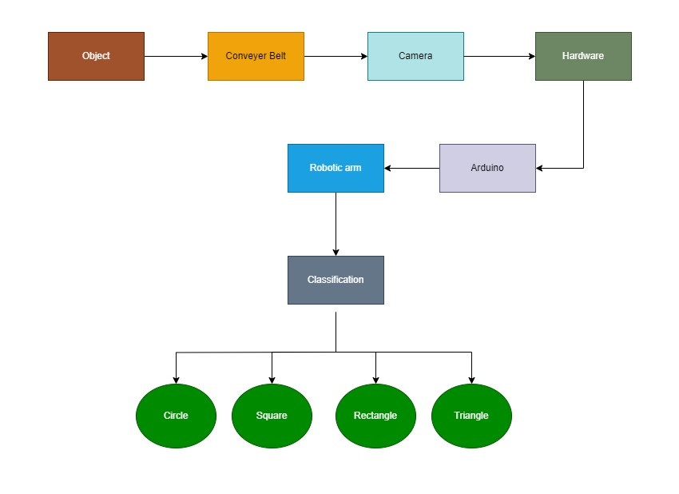
Fig 3.2.1 : Work Flow of the Propsed Model
The above figure is a block diagram that outlines the workflow of the object sorting system based on shape. It uses a conveyor belt to transport objects past two cameras for image capture. Then, a computer with OpenCV software analyzes the captured frames to classify objects by shape (triangle, rectangle, square, circle).

- METHODOLOGY & DESIGN
  - System Overview
- Conveyor Belt System
The purpose of the conveyor belt system is to move objects under the camera for shape detection. The system comprises several key components, including a conveyor belt and a motor. The conveyor belt is a continuous loop that transports objects, while the motor drives the conveyor belt, ensuring its continuous movement.

- Camera and Computer Vision System
The purpose of this system is to capture images of objects on the conveyor belt and process these images to detect their shapes. The main components include a camera and a computer or Raspberry Pi. The camera is positioned above the conveyor belt to capture images of the objects, while the computer or Raspberry Pi runs image processing algorithms. The image processing steps are as follows: first, the camera captures images; then, the images are preprocessed by converting them to grayscale and blurring them to reduce noise. Next, the Canny edge detection algorithm is applied to identify object boundaries. Finally, contours are detected and analyzed to determine the shape of the object, such as a triangle, square, or circle.
- Communication Interface
The purpose of this system is to transfer the detected shape information from the computer vision system to the Arduino. This is achieved using serial communication, such as pySerial, which sends data from the computer running the vision algorithms to the Arduino. The computer encodes the shape information and transmits it via a serial connection, allowing the Arduino to receive and utilize the data for further processing or actions.
- Arduino and Robotic Arm
The purpose of this system is to classify objects by controlling a robotic arm based on received shape information. The key components include an Arduino board and a robotic arm. The Arduino board receives shape data from the computer and controls the robotic arm, which moves to predefined positions to classify objects based on their shapes. The Arduino program involves serial reading, where the Arduino reads the shape data from the serial connection. It then performs shape-based classification, interpreting the shape data and moving the robotic arm accordingly. Different shapes correspond to different positions or actions of the robotic arm. Servo control is utilized to program the robotic arm, typically controlled by servos, to move to specific angles to place objects into designated bins or areas based on their shapes. The integration and workflow of the system are as follows: objects move along the conveyor belt, the camera captures their images, and the captured images are processed to detect shapes. The detected shape information is then sent to the Arduino via serial communication, and the Arduino controls the robotic arm to classify the objects based on the received shape information.
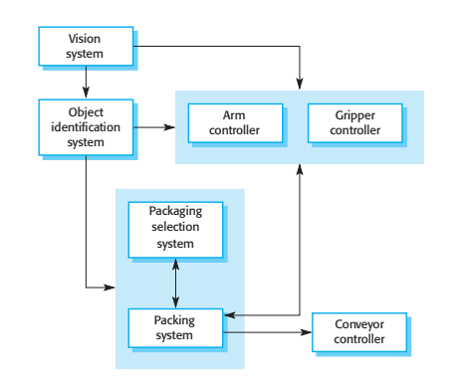
Fig 4.1. : Architecture of a packing robot control system

The above figure is a block diagram outlines the workflow of a packing robot control system, where components like vision system, object identification, and gripper controller collaborate to automate the packing process.
- Results
This section discusses the system designed for this project; it shows the results acquired by testing the system; analyze the results to contextualize them. The completed system consists of the robotic arm, the user interface, and the frame, consisting of the camera mount and the workspace for the robotic arm.Hardware part of the system is shown in Fig 5.1 .
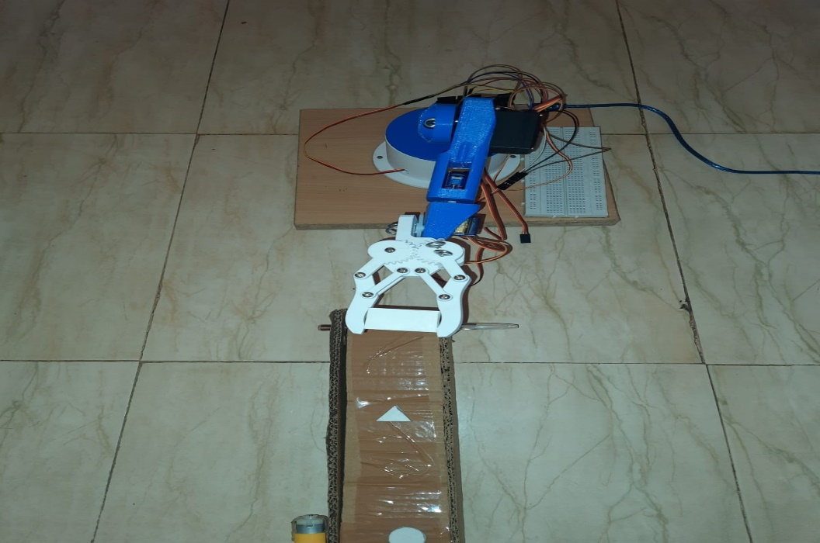
Fig 7.1. : Hardware Part of the System
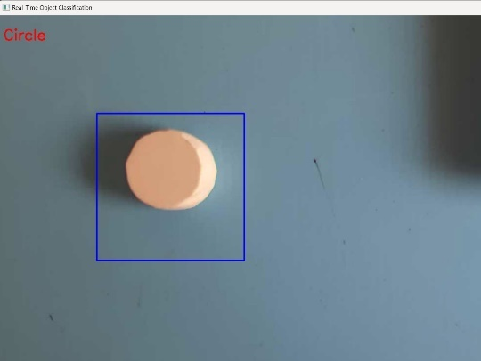 | 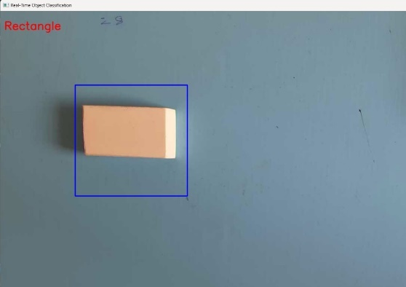
Fig 7.2 : Classification of Circle | Fig 7.3 : Classification of Rectangle
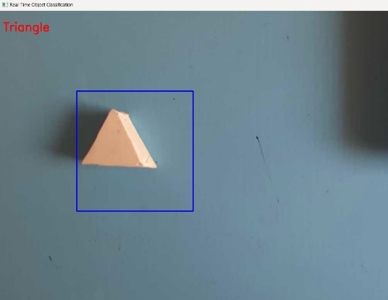 | 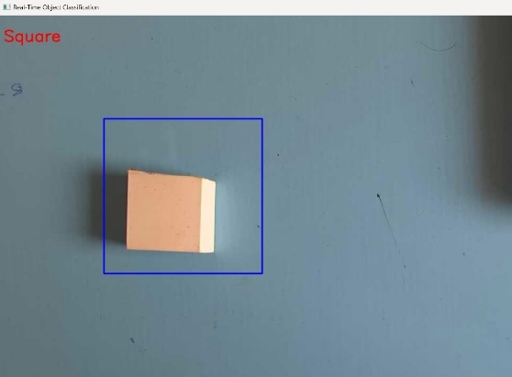
Fig 7.4 : Classification of Triangle | Fig 7.5 : Classification of Square

The above four images describes the Classification of different shapes like Square, Rectangle, Circle, Triangle.
- Conclusion
This project provides a foundation for developing a practical, cost-effective object sorting system suitable for specific needs in various industries. By addressing the limitations and exploring further advancements, this approach has the potential to streamline sorting processes, improve efficiency, and minimize human error in warehouse operations and other applications. The successful implementation of contour-based recognition with Arduino opens doors for several advancements in various industries. Firstly, it enhances accessibility for small businesses by demonstrating the viability of a low-cost, easy-to-implement sorting solution using Arduino. This project empowers smaller businesses and startups to automate sorting tasks that were previously cost-prohibitive with traditional deep learning methods. This can lead to increased efficiency and productivity in their warehouse operations.

Additionally, the real-time processing capabilities of the system enable faster sorting speeds, potentially reducing bottlenecks and expediting delivery times in warehouses and fulfillment centers. This translates to improved customer satisfaction and potentially lower operational costs. Automating sorting tasks also reduces human error associated with manual sorting, leading to improved accuracy and consistency, which can be particularly beneficial in industries with strict quality control requirements. Furthermore, the project serves as a stepping stone for further development in object sorting technologies. By exploring the integration of additional sensors and machine learning techniques, the system's capabilities can be expanded to handle a wider range of objects and complexities, paving the way for even more sophisticated sorting solutions.

References
- Sachin, C., Manasa, N., Sharma, V., & AA, N. K. (2019, November). Vegetable classification using you only look once algorithm. In 2019 International Conference on Cutting-edge Technologies in Engineering (ICon-CuTE) (pp. 101-107). IEEE.
- Kakde, Y., Bothe, N., & Paul, A. (2019). Real life implementation of object detection and classification using deep learning and robotic arm. Proceedings of Recent Advances in Interdisciplinary Trends in Engineering & Applications (RAITEA).
- Kale, V. R., & Kulkarni, V. A. (2013). Object sorting system using robotic arm. International Journal of Advanced Research in Electrical, Electronics and Instrumentation Engineering, 2(7), 3400-3407.
- Poda, X., & Qirici, O. (2018). Shape Detection and Classification Using OpenCV and Arduino Uno. RTA-CSIT, 2280, 128-136.
- Abdullah-Al-Noman, M., Eva, A. N., Yeahyea, T. B., & Khan, R. (2022). Computer vision-based robotic arm for object color, shape, and size detection. Journal of Robotics and Control (JRC), 3(2), 180-186.
- Singh, T., Dhaytadak, D., Kadam, P., & Sapkal, R. J. (2016). Object sorting by robotic arm using image processing. International Research Journal of Engineering and Technology (IRJET), 3(4), 2395-0056.
- Sriramguru, A., Vishwa, A., Yogeshwaran, D., & Yogessh, B. S. (2020). Arduino based Automatic Material Sorting Machine Using Open CV and Python 2.7 IDLE.
- Fan, Z., Li, Z., & Li, W. (2018). Object Detection and Sorting by Using a Global Texture-Shape 3D Feature Descriptor. arXiv preprint arXiv:1802.01116.
- Kumar, R., Lal, S., Kumar, S., & Chand, P. (2014, November). Object detection and recognition for a pick and place robot. In Asia-Pacific world congress on computer science and engineering (pp. 1-7). IEEE.
- Baballe, M. A., Bello, M. I., Abdulkadir, Z., & Garbadiso, G. B. (2022). Study on Cabot's Arms for Color, Shape, and Size Detection. Global Journal of Research in Engineering & Computer Sciences, 2(2), 48-52.
- Fadhil, A. T., Abbar, K. A., & Qusay, A. M. (2020, February). Computer Vision-Based System for Classification and Sorting Color Objects. In IOP Conference Series: Materials Science and Engineering (Vol. 745, No. 1, p. 012030). IOP Publishing.
- Intisar, M., Khan, M. M., Islam, M. R., & Masud, M. (2021). Computer Vision Based Robotic Arm Controlled Using Interactive GUI. Intelligent Automation & Soft Computing, 27(2).
- SNEHA, S., & NAYANA, R. DESIGN AND IMPLEMENTATION OF ROBOT ASSISTED ARDUINO BASED OBJECT RECOGNITION AND SORTING.
- Lahoti, J., Sn, J., Krishna, M. V., Prasad, M., Rajeshwari, B. S., Mysore, N., & Nayak, J. S. (2024). Multi-class waste segregation using computer vision and robotic arm. PeerJ Computer Science, 10, e1957.
- Kumar, V., Wang, Q., Minghua, W., Rizwan, S., Shaikh, S. M., & Liu, X. (2018, April). Computer vision based object grasping 6DoF robotic arm using picamera. In 2018 4th International Conference on Control, Automation and Robotics (ICCAR) (pp. 111-115). IEEE.
- Maity, S., Chakraborty, T., Pandey, R., & Sarkar, H. YOLO (YOU ONLY LOOK ONCE) ALGORITHM-BASED AUTOMATIC WASTE CLASSIFICATION SYSTEM.

